# **NO_CAPTION null**

EE 463

STATIC POWER CONVERSION-I

HARDWARE PROJECT SIMULATION REPORT

Orhun TAŞOĞLU 2094506

Mert ZEYBEK 2167682

Kutay DELİBAŞ 2093599

Submission Date: 04.12.2019

# INTRODUCTION

This report includes details of 3 Phases 1 Company’s topology selection, computer simulation results of the topology and component selections for driving a DC Motor with either a single phase or 3 phase adjustable AC voltage input.

# TOPOLOGY SELECTION

Our first aim is converting AC input to DC input which can be done by either using diode or thyristor rectifiers. Using thyristor switches are advantageous since controlling firing angles also enables us to control DC voltage level. Speed of the motor is proportional to DC voltage applied to armature winding and controlling its speed is our second aim. However, synchronization of gate signals might be problematic in implementation. In single phase thyristor rectifier, this problem becomes easier due to number of thyristors but ripple frequency of a single phase rectifier is 100 Hz which is one third of the 3 phase case. Lower ripple frequency means a filter with lower corner frequency needs to be used which would require higher inductance and capacitance in the filtering elements.Another problem with the single phase thyristor rectifier topology is requirement for components with higher current rating in order to transfer enough power.Cooling such stressed component would be another issue. As a result, both thyristor topologies have some disadvantages.

On the other hand, using a diode rectifier topology does not have a problem like synchronization of the gate signals and 3 phase input can be used. The problem with the diode rectifier is we cannot control output voltage. Hence, it would not be possible to control the speed as well. In order to achieve both our goals with diode topology, we need another stage to control DC output. Since our voltage output from previous stage is high enough and we need to lower it, our DC-DC converter topology will be buck converter. Buck converter is not hard to implement but requires a PWM signal to control on and off state of the transistor. For the buck converter, there are 2 main considerations while designing. Firstly, for the filtering elements, L and C value will be chosen such that they are high enough to make output ripple small. But they shouldn’t be the largest possible values, since they become a lot more expensive and cause more loss.Effect of corner frequency of the filter and switching frequency can be seen in equation (1) where D is the duty cycle, fc is the corner frequency, fs is the switching frequency, while ΔVo and Vo are output voltage ripple and average output voltage. In this equation it can be seen that voltage ripple is related with square of ratio of two frequencies.

$ΔVo/Vo=π^{2} /2 * (1-D) * (fc/fs)^{2}$ (1)

For example, assuming 10 kHz switching operation, corner frequency should be at most 1 kHz in order to see 1% ripple at the output. Various L and C values were chosen and simulated to see their effect.

However, since our load is a motor which behaves like a filter, external filtering turned out to be unnecessary when simulations are carried out. Therefore, the filtering elements are eliminated from the design. Another challenge would be to find an inductor that can carry the high current needed by the motor.

Second one is the switching element, which can either be a mosfet or IGBT. We decided to use low side N-MOSFET buck converter topology since it is easier to control because it is ground referenced. Although output cannot be ground referenced in this case, in other words, it is floating.However, this will not cause a problem to us since we will drive a motor. To conclude, 3-phase diode rectifier and buck converter with low side switching will be our topology to implement.

# SIMULATION RESULTS

The full-diagram for all parts of the project is given in Figure 1.

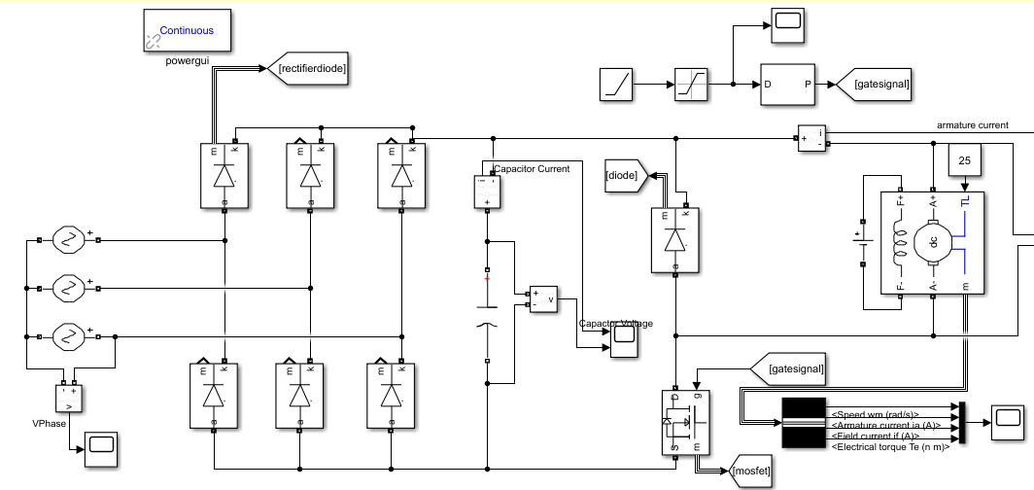

*Figure 1. Overall Simulation Model*

First, since we aim for robustness bonus, the output should be able to supply at least 1.6kW. We set our voltage levels in a way that for duty cycle of 0.9, our motor generates 1.8kW. To be able to reach this duty cycle without much stress on switching components, we decided to use soft-starting. By increasing the duty cycle to 0.9 in 5 seconds, the high starting current demand of motor is suppressed. In Figure 2, duty cycle is directly set to 0.9 from beginning. This caused a huge current surge at the beginning. As a result, we need to select components with much higher current ratings, also risk damaging the motor.

On the other hand, when soft-starting is implemented, maximum current is 25A, reduced to one fourth of the former value. In Figure 3, the reason why we see 25A at the beginning is that of changing average voltage induces a voltage on the windings, therefore causing a higher current. After the motor stabilizes, current drops to 15A, the regular operating point.

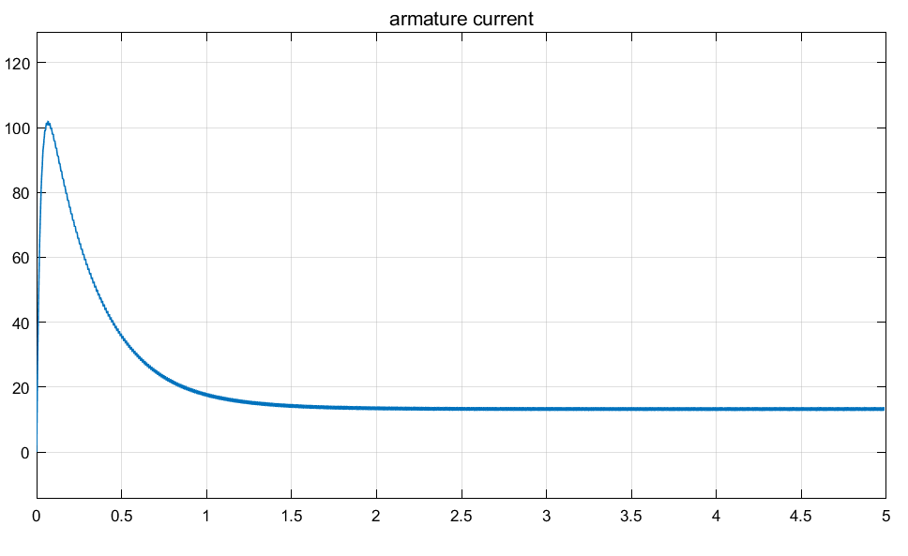

*Figure 2.Graph of Output Current for Constant Duty Cycle 0.9.*

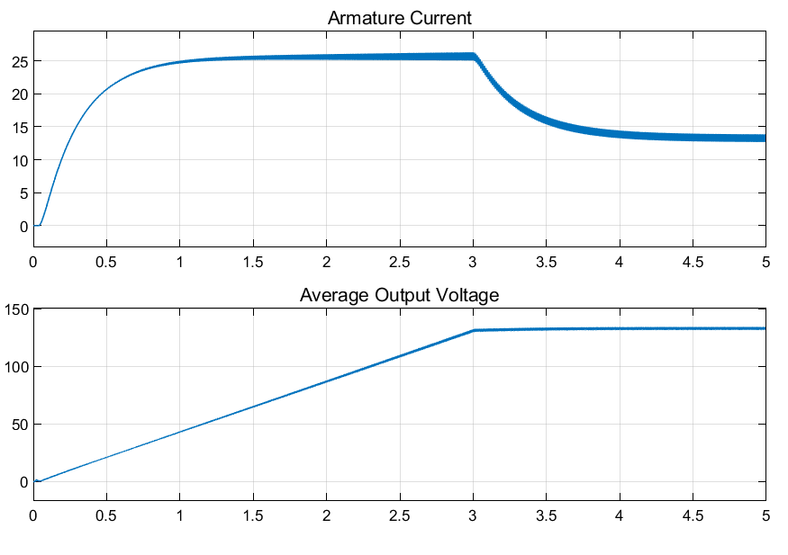

*Figure 3. Graph of Output Voltage and Currents for Duty Cycle slowly increased to 0.9*

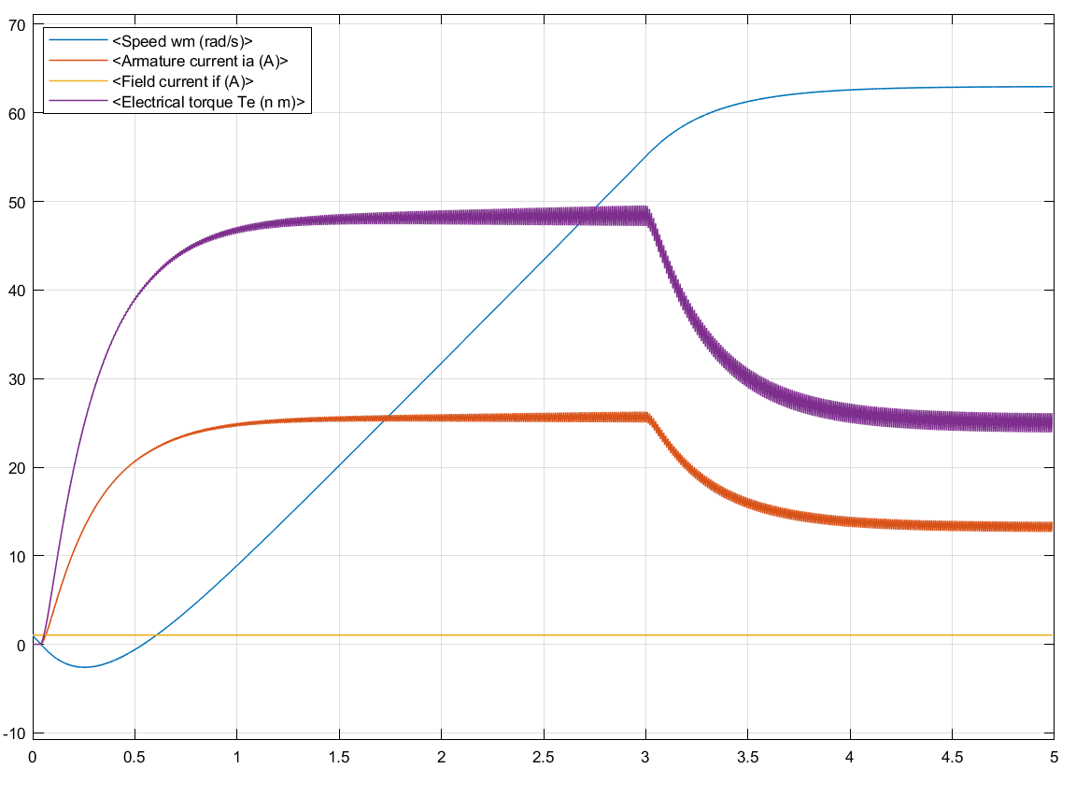

*Figure 4.* Graph of Motor Behavior for duty cycle slowly increased to 0.9

In the following figures, stress tests of our components are given for slowly increasing duty cycle to 0.9. Components for real implementation will be chosen based on these results.

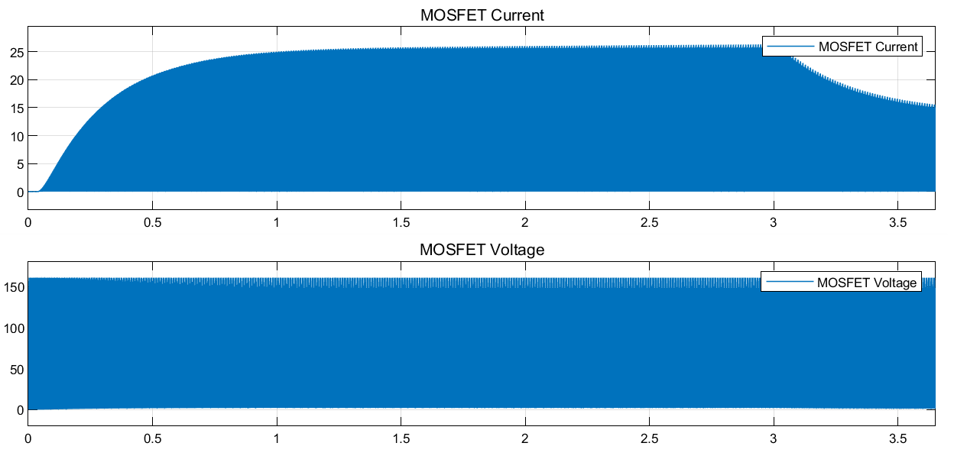

*Figure 5. Graph of MOSFET Current and Voltage for Duty Cycle slowly increased to 0.9*

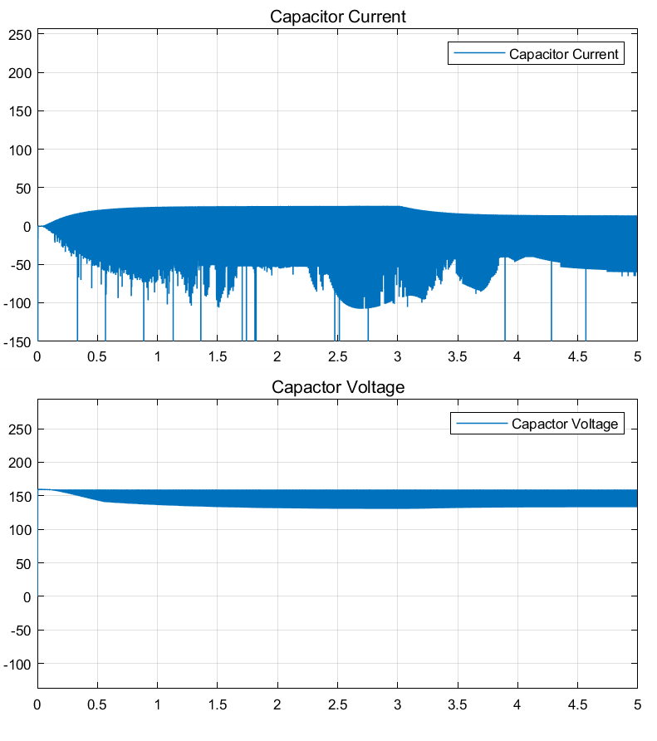

*Figure 6. Graph of Capacitor Current and Voltage for Duty Cycle slowly increased to 0.9*

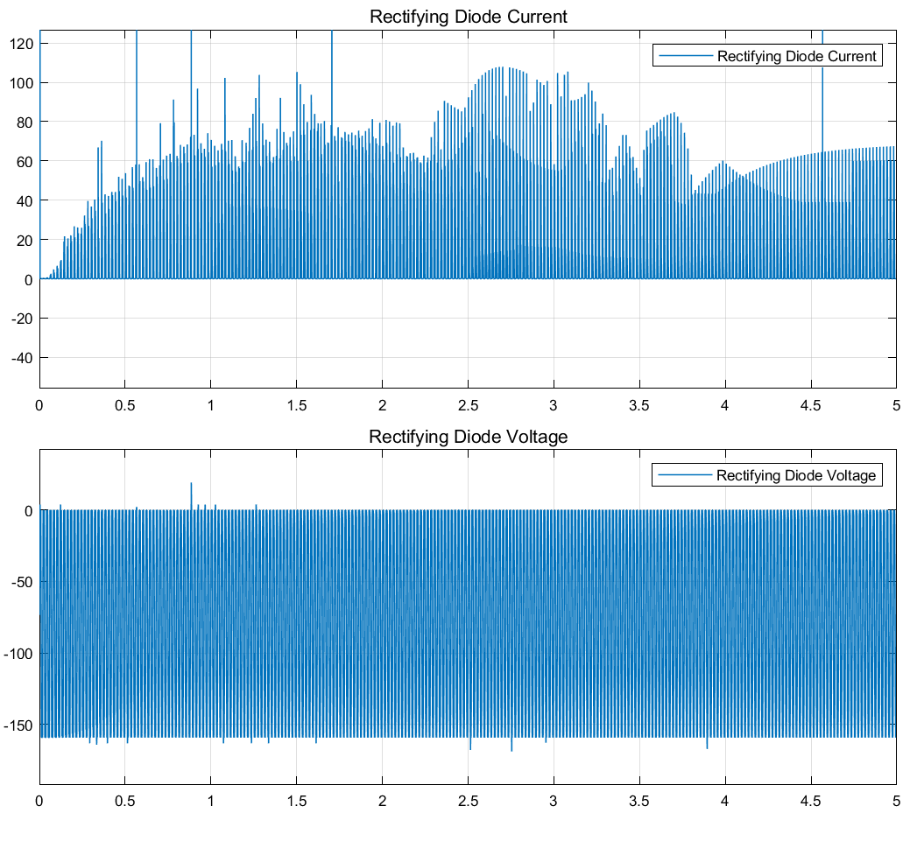

*Figure 7. Graph of Rectifying Diode Current and Voltage for Duty Cycle slowly increased to 0.9*

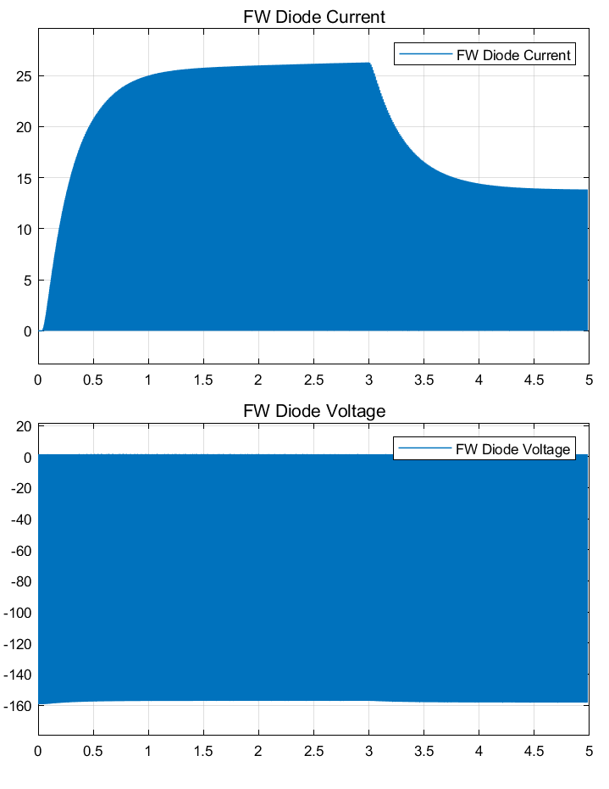

*Figure 8. Graph of Freewheeling Diode Current and Voltage for Duty Cycle slowly increased to 0.9*

# COMPONENT SELECTION

Components are selected such that the current and voltage ratings are slightly higher then simulation results for highest duty cycle.

## Rectifier Elements

### 1.1 Rectifying diodes

6 of ESAF92-03R diode TO247 with 60A 300V ratings can handle the stresses seen in Figure-7.

### 1.2 Capacitor

With Figure-6 in consideration, 1000uF 200V capacitor 10mm 30x40mm(from direnc.net) will be good for regulating DC side of the rectifier.

## DC-DC Converter Elements

### 2.1. Transistor

According to Figure-5, we observed 160 V and 25 A stress on switching element in DC-DC converter. To be on the safe side, we decided on 2 possible options which have higher ratings than the maximum values. One of them is IRFPN250N N-MOSFET, whose current rating is 30 A, and voltage rating is 250 V. Another option is using IXGH24N60C4D1 N-channel IGBT with the same current rating but voltage rating is 600 V. Its voltage rating is more than enough but it is hard to find IGBTs with lower ratings and it is also available in the laboratory. However, our main choice is MOSFET.

### 2.2. PWM Generator

Our first choice is TL494. One of the options is using a 555 timer circuit.Another option is 3525 or UC3845, for soft starting ease of design. We will do research for simple designs and decide the topology. A microcontroller might be used too.

### 2.3. Free-Wheeling Diode

Figure-8 shows us that we need to choose a diode which can block 160 V and can carry 25 A. SDUR3020W diode with 30 A and 200 V ratings is good for this since its rating are not too high but still safe.

# CONCLUSION

While preparing this report, we had a chance to observe working characteristics of our circuit design,We have modeled DC motor in Simulink as the load and measured critical values for choosing the components. By running simulations, we have seen stresses on the components that we will choose and it enabled us to decide on which commercial products we are planning to use. We also made alterations in the design of buck converter. We also decided to use soft start to avoid high initial currents due to the DC motor characteristics. We modeled it with a ramp input for the duty cycle. We will use a soft starting topology for PWM generator.

To conclude, our work in this report will be useful once we start to implement our hardware project.